Employee Demographic Information: - Used to link the employee signed up to their human resource and payroll system. Limited access once per device.

https://www.surveymonkey.com/r/HDNSFDK
QR_Code_HDNSFDK

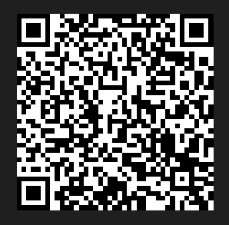

Bi-weekly Employee Time Certification – Used to collect worked times for non-exempt staff
https://www.surveymonkey.com/r/5HGB67Q
QR_code_5HGB67Q

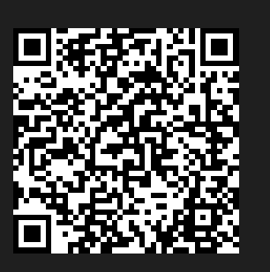

Exempt Employee Daily Work Log – Used to collect DAYS worked at the facilities
https://www.surveymonkey.com/r/Y3GL5KT
QR_code_Y3GL5KT

