ShareFile
How to Guide

January 25, 2021

Login Screen

- Navigate to Uabmedicine.sharefile.com
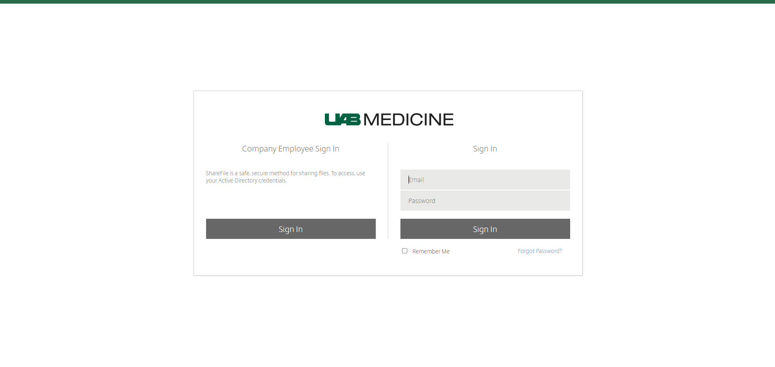
- User will select Company Employee Sign In if they are a Uabmc employee.
- Clients will select the right hand side login if they do not have a Uabmc email address.
- Once logged in you will see your Homepage for Sharefile.

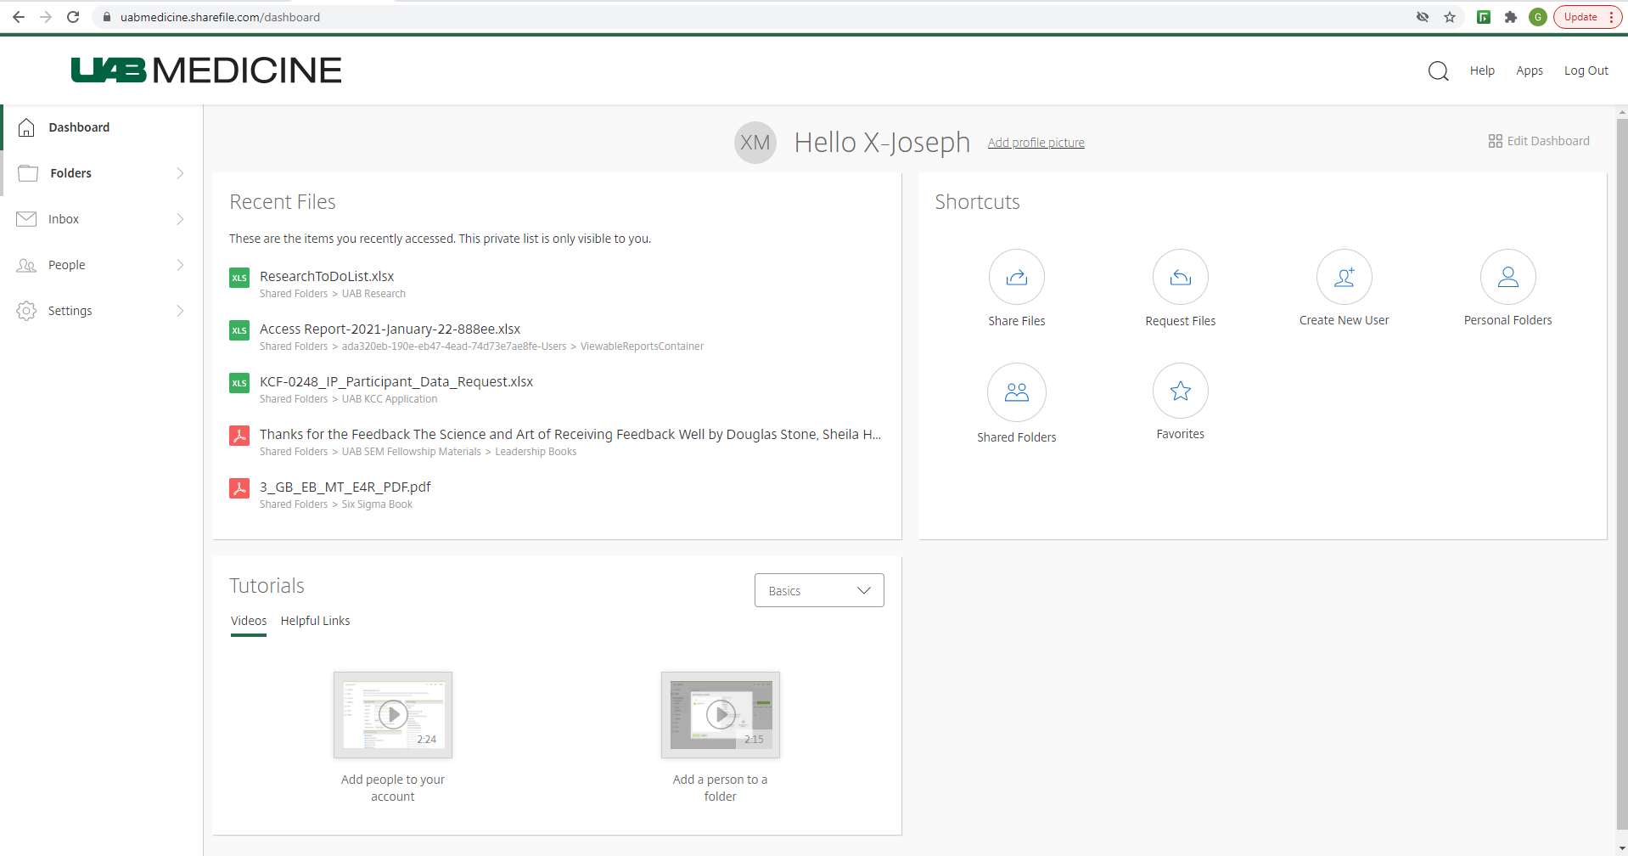
Creation of Personal Folders:
- Select Personal Folders under the Folders option from the dashboard.
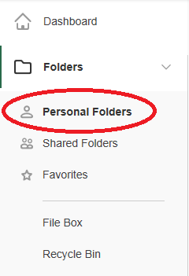

- Click the blue plus sign and select Create Folder.
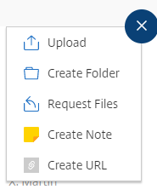

- Give folder a name and description of contents of folder or its purpose.
Note: Description is optional but may be helpful.
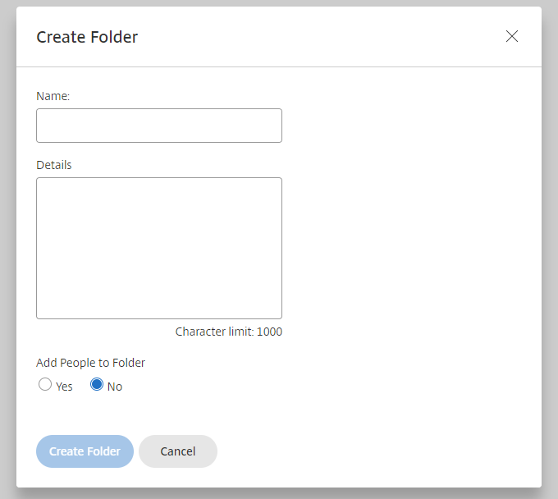

- From here, you can drag and drop items into the newly created folder. You can also click on Browse Files to select from the pop up window. You will notice towards the bottom, there are two check boxes. You use these when you wish to receive notification that someone has downloaded or uploaded to the folder.
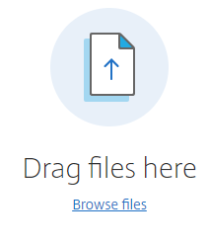

- Once the folder has been created, you also have the option of adding users to your personal folder. Click on the People on This Folder tab.
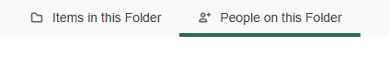
- In the Add People to Folder window, you will have the ability to add a user by searching from them in the Select window. This search should be able to locate anyone in the address book as well as any Client created accounts (None, staff accounts). You can create client accounts by clicking the Create New User button.
You are also able to set user folder permissions as well as notify new users that they now have access to your personal folder. Applying settings to subfolders allows you to have the permissions you created transfer to not only the root folder but all subfolders (Folders within folders).

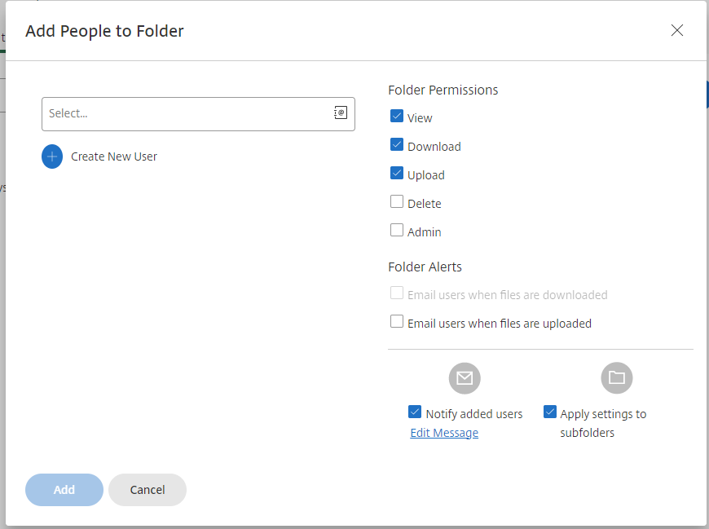

- Users will be sent an email (If you selected Notify Added Users) that will inform them that they have been given access to a folder. Once inside they will then need to create a password for themselves.
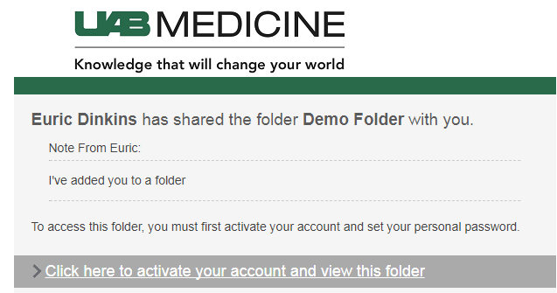
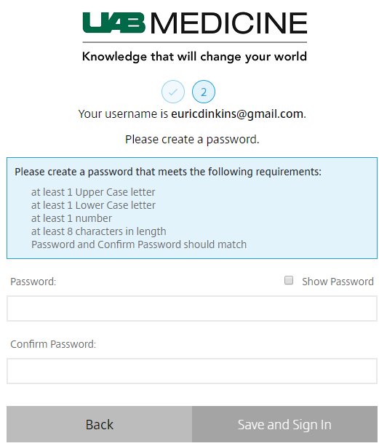

- You also can remove users, notify uses of their access, and change their permission levels. (Note: you can clone users if you wanted to add new users to the folder with the same access right as an existing user.
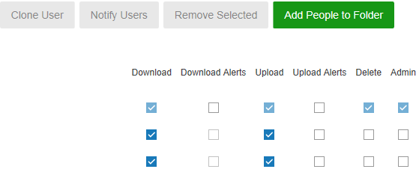
Shared Folders and Favorites:
Shared folders appear under the Personal Folders in the dropdown menu on the left. Here any folders other users have created that they have shared with you will appear. Your access to these folders permissions are maintained by the original creator of the file.
Favorites, is where any folders you access often would be listed if you choose to check the star next to the folder. This comes in handy, when you are working with several files making document location a faster process. Favorite files can be chosen as needed.
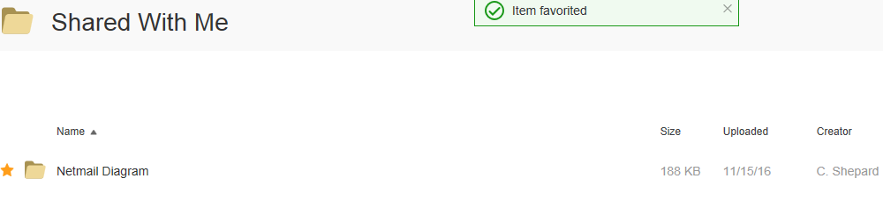

File Box:
File box is a temporary storage location that is provided by FileShare. Items stored here will be kept for up to 180 days. Documents that need to be stored longer should be moved to a folder of your creation or risk deletion.
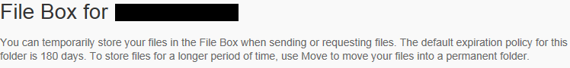

Shortcuts:
Shortcuts can be access from the dashboard. Here you will be able to quickly move about the ShareFile system to accomplish various task.
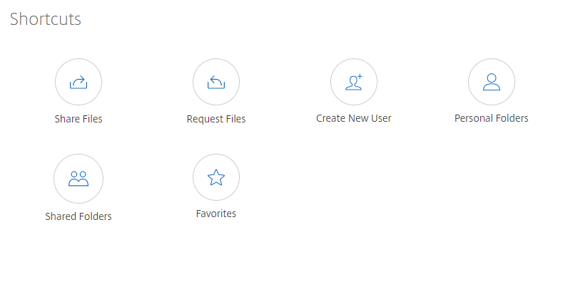

When sharing a file via the shortcut menu you will get the option to send a document via email or you can send a link to the user that will take them to the location where the file is stored.
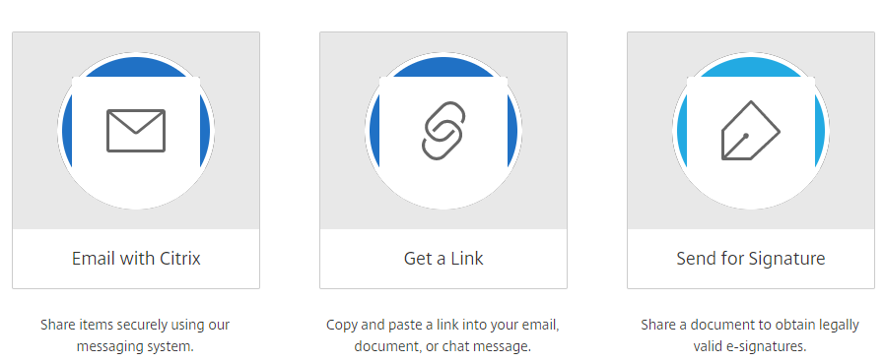

Email with ShareFile: Just like sending a standard email, ShareFile ask for standard information, such as recipient, subject, and message. When selecting the file to send, ShareFile gives you the option to pull a file from either one of the files within ShareFile or from your local computer.
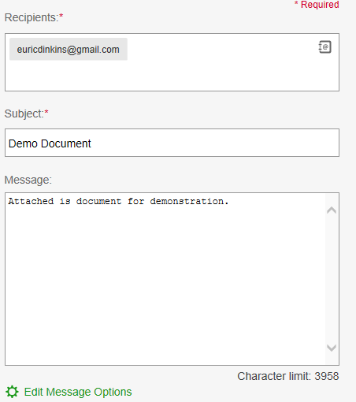
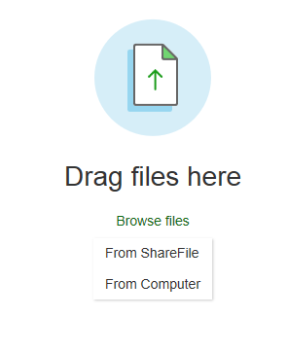
The person that has received the file will receive an email that will inform them who the document came from as well when that document expires and the option to download for permanent storage.
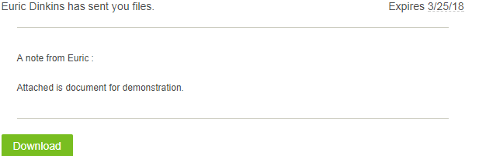

Get a Link: The Get a Link feature allows you to upload a document and rather than send a file to the intended recipient, they instead will receive a link that will direct them to Sharefile in order to access it. This is great for users outside of the company who may not need access to documents stored in ShareFile often.
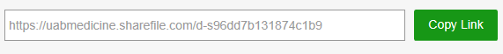
Email sent to user who are not currently enrolled on ShareFile will be prompted to create an account before accessing the file.

Request File:
Request With ShareFile work just like Email With ShareFile but in the other direction. Instead of sending a document, you are making a request to another ShareFile user for an anticipated document.
Instead of choosing a document to upload, you will choose the location where the requested document will be saved.
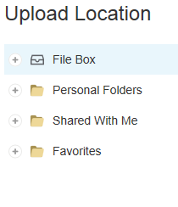
The other client will receive an email asking that you upload the requested document. Again, by default, the uploaded document will be saved in the predetermined location you set before asking.
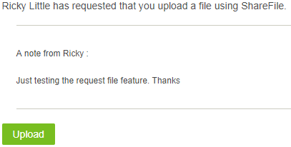

Get a Link works in the same fashion as it does when sending a document. But, in this case instead of the link giving access to the other user to access a document. It will instead, provide a link for them to upload a document that you will receive. Again, the document location is saved in a predetermined location.
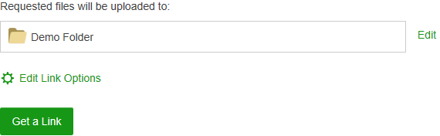
Link sent to user:
